**Data-Driven insights on Olympic Sports Participation and**

**Performance**

**Project on SmartInternz DATA**

**ANALYTICS**

**Submitted by:**

BALA S - 811320104003

KATHIRESAN S -811320104012

SANTHOSH S - 811320104024

SURYA PRAKASH P-811320104302

# INTRODUCTION

## Overview

The Olympic Games, as one of the most prestigious international sporting events, capturesthe attention of millions worldwide. Athletes from diverse backgrounds and nations cometogether to compete in a wide array of sports disciplines, showcasing their talent, dedication, and skill. Behind this grand spectacle lies a wealth of data waiting to be explored and analyzed.

This data analytics project focuses on gaining a deeper understanding of Olympic sports participation and performance through a data-driven approach. By harnessing the power ofdata, we aim to uncover insights that can shed light on the factors influencing sports participation and contribute to the improvement of athletic performance.

The primary objective of this project is to explore and analyze historical data encompassing past Olympic Games. This comprehensive dataset includes athlete profiles, information on various sporting events, and performance metrics. By analyzing this data, we can identify patterns, trends, and correlations that may exist within the Olympic sports landscape.

## Purpose

The purpose of this data analytics project is to conduct a comprehensive analysis of Olympic sports participation and performance using data-driven insights. The Olympic Games is a globally renowned sporting event that brings together elite athletes from around the world to compete in a wide range of sports disciplines. By harnessing the power of data, this project seeks to delve into the wealth of information available and extract meaningful insights that can contribute to a deeper understanding of the factors influencing sports participation and ultimately enhance performance outcomes. By analyzing relevant datasets from past Olympic Games, including athlete profiles, sporting events, and performance metrics, this project aims to uncover patterns, trends,and relationships that exist within the data. The **analysis will** encompass various aspects,such as the number of athletes participating in different sports disciplines, the representation of countries across different editions of the Olympics, and the performance metrics associated with each sport.

## LITERATURE SURVEY

* 1. **Existing problem**

You can describe the current challenges and opportunities in Analyze and visualizing the historical and current data of Olympic sports, such as data quality, availability, diversity, complexity, and relevance. You can also mention the potential benefits and applications of data-driven insights for various stakeholders, such as athletes, coaches, organizers, sponsors, media, and fans.

## References

You can cite some of the existing works that have used data analysis techniques to aspects of Olympic sports, such as performance, participation, medal distribution, equality, economic impact, etc.

Here are some examples of references you



* [Performance Analysis in Olympic Games using Exploratory Data Analysis](https://www.ijrte.org/wp-content/uploads/papers/v7i4s/E2044017519.pdf) [Techniques: This paper uses exploratory data analysis techniques to provide](https://www.ijrte.org/wp-content/uploads/papers/v7i4s/E2044017519.pdf) [comparison between performance of various countries and the contribution of](https://www.ijrte.org/wp-content/uploads/papers/v7i4s/E2044017519.pdf) [each country in Olympics](https://www.ijrte.org/wp-content/uploads/papers/v7i4s/E2044017519.pdf).



* [Data-Driven insights on Olympic Sports Participation and Performance: This](https://github.com/Kavin2028/NM2023TMID12757) [is a GitHub repository that contains a web app providing data-driven insights](https://github.com/Kavin2028/NM2023TMID12757) [on Olympic sports participation and performance using Python Flask and IBM](https://github.com/Kavin2028/NM2023TMID12757) [Cloud](https://github.com/Kavin2028/NM2023TMID12757)

## problem statement

The purpose of the Olympic Games Analysis is to visualize data that will help Readers understand how countries have performed historically in the Summer Olympic Games(with the possibility to select Own country)

## IDEATION & PROPOSED SOLUTION

* 1. **Empathy Map Canvas**

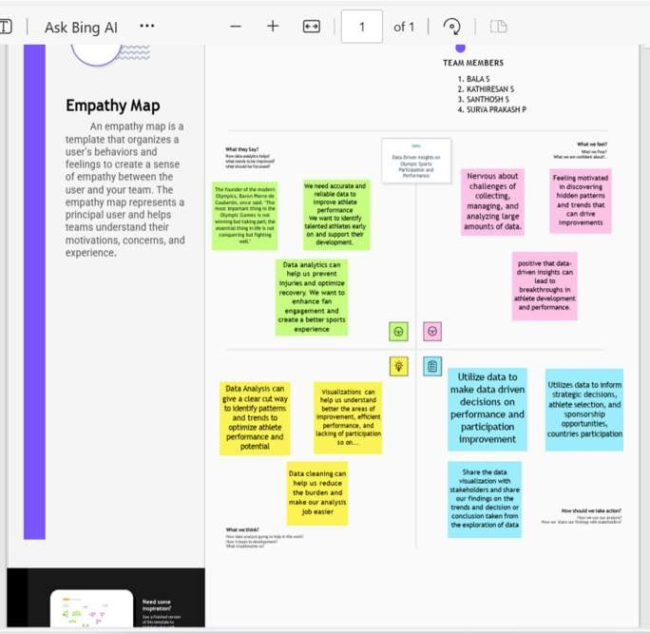

## Ideation & Brainstorming

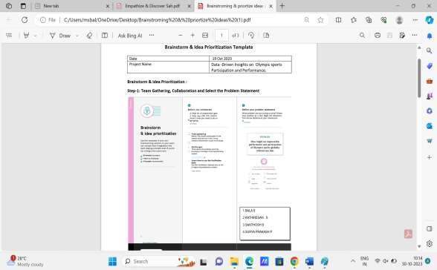

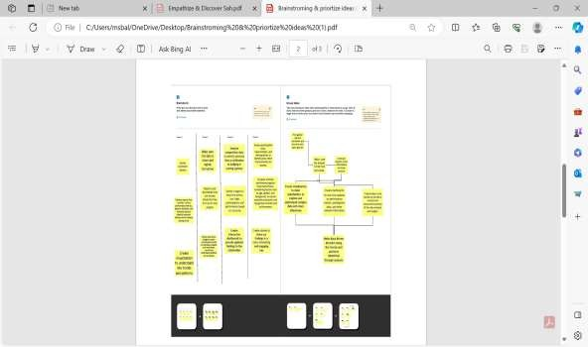

.

## REQUIREMENTS ANALYSIS

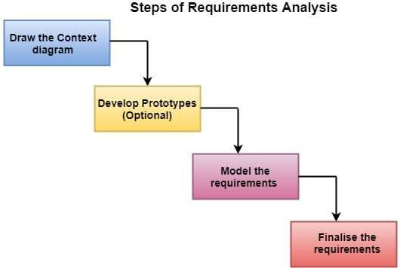

1. **PROJECT DESIGN**

## Dataflow Diagram

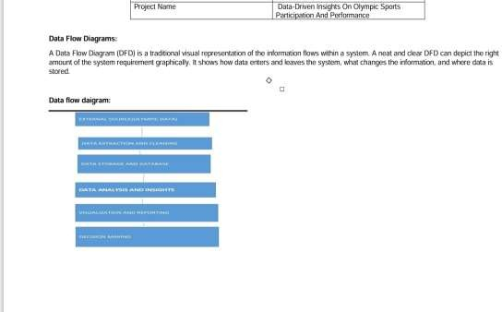

* 1. **Solution Architecture**

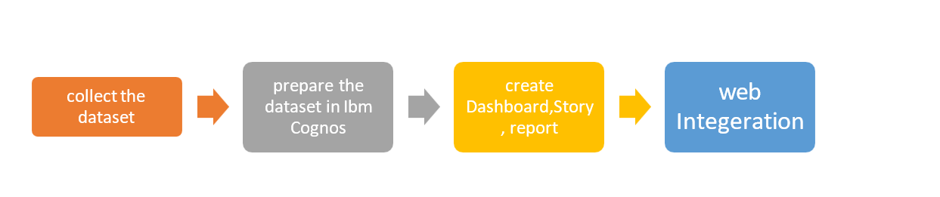

## TECHNICAL ARCHITECTURE

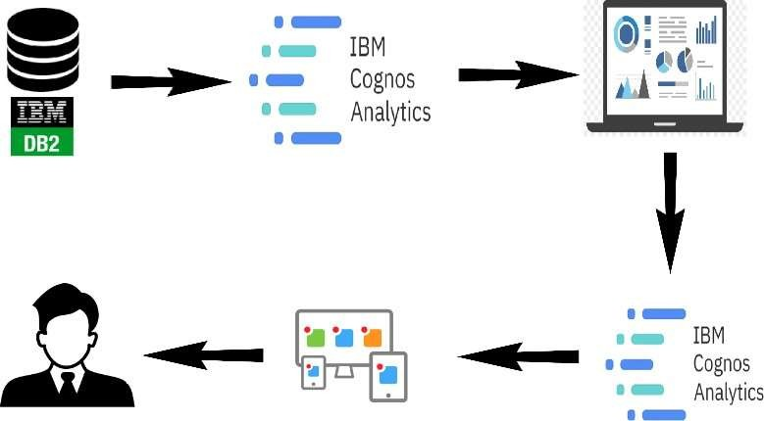

* Analyze IBM DB2 , IBM Cognos Analytics.

.

## CODING & SOLUTIONING

Index.html

<!DOCTYPE html>

<html lang="en">

<head>

<meta charset="utf-8">

<meta content="width=device-width, initial-scale=1.0" name="viewport">

<title>Olympics Data Analysis</title>

<meta content="" name="description">

<meta content="" name="keywords">

<!-- Favicons -->

<link href="static/assets/img/favicon.png" rel="icon">

<link href="static/assets/img/apple-touch-icon.png" rel="apple-touch-icon">

<!-- Google Fonts -->

<link rel="preconnect" href="https://fonts.googleapis.com">

<link rel="preconnect" href="https://fonts.gstatic.com" crossorigin>

<link href=["https://fonts.googleapis.com/css2?family=Open+Sans:ital,wght@0,300;0,400;0,500;0,6](https://fonts.googleapis.com/css2?family=Open%2BSans%3Aital%2Cwght%400%2C300%3B0%2C400%3B0%2C500%3B0%2C6) 00;0,700;1,300;1,400;1,600;1,700&family=Poppins:ital,wght@0,300;0,400;0,500;0,600;0,700;

1,300;1,400;1,500;1,600;1,700&family=Inter:ital,wght@0,300;0,400;0,500;0,600;0,700;1,300

;1,400;1,500;1,600;1,700&display=swap" rel="stylesheet">

<!-- Vendor CSS Files -->

<link href="static/assets/vendor/bootstrap/css/bootstrap.min.css" rel="stylesheet">

<link href="static/assets/vendor/bootstrap-icons/bootstrap-icons.css" rel="stylesheet">

<link href="static/assets/vendor/fontawesome-free/css/all.min.css" rel="stylesheet">

<link href="static/assets/vendor/glightbox/css/glightbox.min.css" rel="stylesheet">

<link href="static/assets/vendor/swiper/swiper-bundle.min.css" rel="stylesheet">

<link href="static/assets/vendor/aos/aos.css" rel="stylesheet">

<!-- Template Main CSS File -->

<link href="static/assets/css/main.css" rel="stylesheet">

<!-- =======================================================

* Template Name: Logis
* Updated: May 30 2023 with Bootstrap v5.3.0
* Template URL: https://bootstrapmade.com/logis-bootstrap-logistics-website-template/
* Author: BootstrapMade.com
* License: https://bootstrapmade.com/license/

======================================================== -->

</head>

<body>

<!-- ======= Header ======= -->

<header id="header" class="header d-flex align-items-center fixed-top">

<div class="container-fluid container-xl d-flex align-items-center justify-content- between">

<a href="{{url_for('home')}}" class="logo d-flex align-items-center">

<!-- Uncomment the line below if you also wish to use an image logo -->

<!-- <img src="assets/img/logo.png" alt=""> -->

<h1>Olympics - Data Analysis</h1>

</a>

<i class="mobile-nav-toggle mobile-nav-show bi bi-list"></i>

<i class="mobile-nav-toggle mobile-nav-hide d-none bi bi-x"></i>

<nav id="navbar" class="navbar">

<ul>

<li><a href="{{url_for('home')}}" class="active">Home</a></li>

<li><a href="{{url_for('story')}}">Story</a></li>

<li><a href="{{url_for('insights')}}">Report</a></li>

<li><a href="{{url_for('dashboards')}}">Dashboards</a></li>

<li><a href="{{url_for('about')}}">About us</a></li>

</ul>

</nav><!-- .navbar -->

</div>

</header><!-- End Header -->

<!-- End Header -->

<!-- ======= Hero Section ======= -->

<section id="hero" class="hero d-flex align-items-center">

<div class="container">

<div class="row gy-4 d-flex justify-content-between">

<div class="col-lg-6 order-2 order-lg-1 d-flex flex-column justify-content- center">

<h2 data-aos="fade-up">Data-driven insights on Olympic sports participation and performance</h2>

<p data-aos="fade-up" data-aos-delay="100">

The modern Olympic Games or Olympics are leading international sporting events featuring summer and winter sports competitions in which thousands of athletes from around the world participate in a variety of competitions. The Olympic Games are held every four years, with the Summer and Winter Games alternating by occurring every four years but two years apart.

</p>

<div class="row gy-4" data-aos="fade-up" data-aos-delay="400" >

<div class="col-lg-3 col-6">

<div class="stats-item text-center w-100 h-100">

<span data-purecounter-start="0" data-purecounter-end="206" data- purecounter-duration="1.5" class="purecounter"></span>

<p>Countries</p>

</div>

</div><!-- End Stats Item -->

<div class="col-lg-3 col-6">

<div class="stats-item text-center w-100 h-100">

<span data-purecounter-start="0" data-purecounter-end="66" data- purecounter-duration="1.5" class="purecounter"></span>

<p>Sports</p>

</div>

</div><!-- End Stats Item -->

<div class="col-lg-3 col-6">

<div class="stats-item text-center w-100 h-100">

<span data-purecounter-start="0" data-purecounter-end="134732" data- purecounter-duration="1.5" class="purecounter"></span>

<p>&nbsp;&nbsp;Participants</p>

</div>

</div><!-- End Stats Item -->

</div>

</div>

alt="">

<div class="col-lg-5 order-1 order-lg-2 hero-img" data-aos="zoom-out">

<img src="static/assets/img/olympics.png" class="img-fluid mb-3 mb-lg-0"

</div>

</div>

</div>

</section><!-- End Hero Section -->

<main id="main">

<!-- ======= About Us Section ======= -->

<section id="about" class="about pt-0">

<div class="container" data-aos="fade-up">

first">

<div class="row gy-4">

<div class="col-lg-6 position-relative align-self-start order-lg-last order-

<img src="static/assets/img/History.webp" class="img-fluid" alt="">

<a href="https://youtu.be/mQ94xbXnYu4" class="glightbox play-btn"></a>

</div>

<div class="col-lg-6 content order-last order-lg-first">

<h3>History</h3>

<p>

The 1896 Summer Olympics, officially known as the Games of the I Olympiad

and commonly known as Athens 1896, was the first international Olympic Games held in modern history. Organised by the International Olympic Committee (IOC), which had been created by French aristocrat Pierre de Coubertin, it was held in Athens, Greece, from 6 to 15 April 1896.

Fourteen nations (according to the IOC, though the number is subject to interpretation) and 241 athletes (all males; this number is also disputed) took part in the games. Participants were all European, or living in Europe, with the exception of the United States team. Over 65% of the competing athletes were Greek. Winners were given a silver medal, while runners-up received a copper medal.

</p>

</div>

</div>

<div class='History' id='viz1688051296025' style='position: relative'>

<noscript>

<a href='#'>

<img alt=' ' src='https:&#47;&#47;public.tableau.com&#47;static&#47;images&#47;Ol&#47;OlympicAtheletd ataset_16880435094160&#47;History&#47;1_rss.png' style='border: none' />

</a>

</noscript>

<object class='tableauViz' style='display:none;'>

<param name='host_url' value='https%3A%2F%2Fpublic.tableau.com%2F' />

<param name='embed_code_version' value='3' />

<param name='site_root' value='' />

<param name='name' value='OlympicAtheletdataset_16880435094160&#47;History'

/>

<param name='tabs' value='yes' />

<param name='toolbar' value='yes' />

<param name='static_image'

value='https:&#47;&#47;public.tableau.com&#47;static&#47;images&#47;Ol&#47;OlympicAthele tdataset_16880435094160&#47;History&#47;1.png' />

<param name='animate_transition' value='yes' />

<param name='display_static_image' value='yes' />

<param name='display_spinner' value='yes' />

<param name='display_overlay' value='yes' />

<param name='display_count' value='yes' />

<param name='language' value='en-US' />

</object>

</div>

<script type='text/javascript'> var divElement =

document.getElementById('viz1688051296025');

var vizElement = divElement.getElementsByTagName('object')[0];

if ( divElement.offsetWidth > 800 )

{ vizElement.style.minWidth='1100px'; vizElement.style.maxWidth='100%'; vizElement.style.minHeight='950px'; vizElement.style.maxHeight=(divElement.offsetWidth*0.75)+'px';

} else if ( divElement.offsetWidth > 500 )

{ vizElement.style.minWidth='1100px'; vizElement.style.maxWidth='100%'; vizElement.style.minHeight='950px'; vizElement.style.maxHeight=(divElement.offsetWidth*0.75)+'px';

} else { vizElement.style.minWidth='1100px'; vizElement.style.maxWidth='100%'; vizElement.style.minHeight='1450px'; vizElement.style.maxHeight=(divElement.offsetWidth*1.77)+'px';

}

var scriptElement = document.createElement('script');

scriptElement.src = 'https://public.tableau.com/javascripts/api/viz_v1.js';

vizElement.parentNode.insertBefore(scriptElement,

vizElement);

</script>

</div>

</section><!-- End About Us Section -->

<!-- ======= Services Section ======= -->

<section id="service" class="services pt-0">

<div class="container" data-aos="fade-up">

<div class="section-header">

<span>SPORTS IN OLYMPICS</span>

<h2>SPORTS IN OLYMPICS</h2>

</div>

<div class="row gy-4">

<div class="col-lg-4 col-md-6" data-aos="fade-up" data-aos-delay="100">

<div class="card">

<div class="card-img">

<img src="static/assets/img/Gymnastics.jpg" alt="" class="img-fluid">

</div>

<h3><a href="#" class="stretched-link">Gymnastics</a></h3>

<p>

Gymnastics combines athleticism, strength, and grace as athletes perform breathtaking acrobatic routines on various apparatus such as the balance beam, uneven bars, vault, and floor exercise, showcasing their flexibility, power, and precision.

</p>

</div>

</div><!-- End Card Item -->

<div class="col-lg-4 col-md-6" data-aos="fade-up" data-aos-delay="200">

<div class="card">

<div class="card-img">

<img src="static/assets/img/Track.webp" alt="" class="img-fluid">

</div>

<h3><a href="#" class="stretched-link">Track & Field</a></h3>

<p>

Track and field events encompass a wide range of athletic disciplines, including sprints, long-distance running, hurdles, high jump, long jump, shot put, discus throw, and javelin throw. Athletes compete in individual events, pushing their physical limits and aiming for faster times, higher jumps, and longer throws.

</p>

</div>

</div><!-- End Card Item -->

<div class="col-lg-4 col-md-6" data-aos="fade-up" data-aos-delay="300">

<div class="card">

<div class="card-img">

<img src="static/assets/img/Swimming.png" alt="" class="img-fluid">

</div>

<h3><a href="#" class="stretched-link">Swimming</a></h3>

<p>

Swimmers compete in various swimming styles such as freestyle, backstroke, breaststroke, and butterfly, showcasing their speed, endurance, and technique. Races range from short sprints to longer distances, and swimmers strive to break records while demonstrating their exceptional skill in the water.

</p>

</div>

</div><!-- End Card Item -->

<div class="col-lg-4 col-md-6" data-aos="fade-up" data-aos-delay="400">

<div class="card">

<div class="card-img">

<img src="static/assets/img/Basketball.jpg" alt="" class="img-fluid">

</div>

<h3><a href="#" class="stretched-link">BasketBall</a></h3>

<p>

Basketball is a fast-paced team sport where players aim to shoot the ball into the opponent's hoop while preventing the other team from scoring. With its high-energy gameplay, skilled ball handling, and strategic teamwork, basketball captivates fans worldwide and showcases exceptional athleticism and coordination.

</p>

</div>

</div><!-- End Card Item -->

<div class="col-lg-4 col-md-6" data-aos="fade-up" data-aos-delay="500">

<div class="card">

<div class="card-img">

<img src="static/assets/img/Football.jpg" alt="" class="img-fluid">

</div>

<h3><a href="#" class="stretched-link">Football</a></h3>

<p>

Football, or soccer, is a globally popular sport that brings together teams competing to score goals by maneuvering a ball into the opponent's net. Combining speed, agility, and tactical play, football demands both individual skill and collective teamwork, captivating audiences with its passion and intensity.

</p>

</div>

</div><!-- End Card Item -->

<div class="col-lg-4 col-md-6" data-aos="fade-up" data-aos-delay="600">

<div class="card">

<div class="card-img">

<img src="static/assets/img/Table Tennis.webp" alt="" class="img-fluid">

</div>

<h3><a href="#" class="stretched-link">Table Tennis</a></h3>

<p>

Table tennis, also known as ping pong, is a fast-paced racket sport played on a table. Players showcase lightning-fast reflexes, precision, and strategic

shot placement as they compete in singles or doubles matches, making table tennis a thrilling sport that requires exceptional hand-eye coordination and agility.

</p>

</div>

</div><!-- End Card Item -->

</div>

</div>

</section><!-- End Services Section -->

<!-- ======= Call To Action Section ======= -->

<section id="call-to-action" class="call-to-action">

<div class="container" data-aos="zoom-out">

<div class="row justify-content-center">

<div class="col-lg-8 text-center">

<h3>Data Analysis</h3>

<p> In this project we have analyzed data to gain insights about Performance of countries, Atheltes and various kind of factors which play a key role in Olympics</p>

<a class="cta-btn" href="{{url_for('insights')}}">Gain Insights</a>

</div>

</div>

</div>

</section><!-- End Call To Action Section -->

<!-- ======= Testimonials Section ======= -->

<section id="testimonials" class="testimonials">

<div class="container">

<div class="slides-1 swiper" data-aos="fade-up">

<div class="swiper-wrapper">

alt="">

get back up.

<div class="swiper-slide">

<div class="testimonial-item">

<img src="static/assets/img/team/Mary Kom.jpeg" class="testimonial-img"

<h3>Mary Kom</h3>

<h4>Indian professional boxer </h4>

<p>

<i class="bi bi-quote quote-icon-left"></i>

It's not about how many times you fall down, but how many times you

<i class="bi bi-quote quote-icon-right"></i>

</p>

</div>

</div><!-- End testimonial item -->

<div class="swiper-slide">

<div class="testimonial-item">

alt="">

<img src="static/assets/img/team/PV Sindhu.jpg" class="testimonial-img"

<h3>PV Sindhu</h3>

<h4>Indian badminton player</h4>

<p>

<i class="bi bi-quote quote-icon-left"></i>

Dreams do come true if you work hard and never give up

<i class="bi bi-quote quote-icon-right"></i>

</p>

</div>

</div><!-- End testimonial item -->

<div class="swiper-slide">

<div class="testimonial-item">

<img src="static/assets/img/team/Usain Bolt.webp" class="testimonial-

img" alt="">

<h3>Usain Bolt</h3>

<h4>Jamaican sprinter</h4>

<p>

<i class="bi bi-quote quote-icon-left"></i>

Don't think about the start of the race; think about the ending

<i class="bi bi-quote quote-icon-right"></i>

</p>

</div>

</div><!-- End testimonial item -->

</div>

<div class="swiper-pagination"></div>

</div>

</div>

</section><!-- End Testimonials Section -->

</main><!-- End #main -->

<!-- ======= Footer ======= -->

<footer id="footer" class="footer">

<div class="container">

<div class="row gy-4">

<div class="col-lg-5 col-md-12 footer-info">

<h2>Olympics Data Analysis</h2>

<p>Hope you found something insightful in our project</p>

</div>

</div>

</div>

</footer><!-- End Footer -->

<!-- End Footer -->

<a href="#" class="scroll-top d-flex align-items-center justify-content-center"><i class="bi bi-arrow-up-short"></i></a>

<div id="preloader"></div>

<!-- Vendor JS Files -->

<script src="static/assets/vendor/bootstrap/js/bootstrap.bundle.min.js"></script>

<script src="static/assets/vendor/purecounter/purecounter_vanilla.js"></script>

<script src="static/assets/vendor/glightbox/js/glightbox.min.js"></script>

<script src="static/assets/vendor/swiper/swiper-bundle.min.js"></script>

<script src="static/assets/vendor/aos/aos.js"></script>

<script src="static/assets/vendor/php-email-form/validate.js"></script>

<!-- Template Main JS File -->

<script src="static/assets/js/main.js"></script>

</body>

</html>

app.py

from flask import Flask,render_template,url_for app = Flask( name )

@app.route("/") def home():

return render_template("index.html",

story_url=url_for("story"), insights_url=url_for("insights"), dashboards_url=url_for("dashboards"), about_url=url_for("about"))

@app.route("/story") def story():

return render_template("story.html")

@app.route("/insights") def insights():

return render_template("insights.html")

@app.route("/dashboards") def dashboards():

return render_template("dashboards.html")

@app.route("/about") def about():

return render_template("about.html")

if name == " main ": app.run(debug=False, port=8000)

## SOLUTIONING

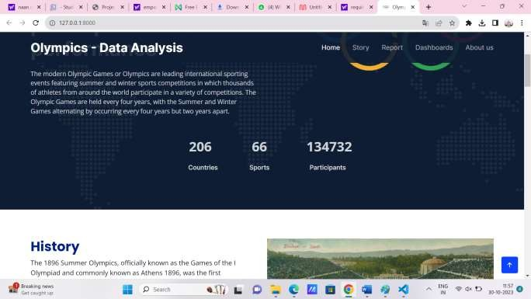

1. **PERFORMANCE TESTING**

Utilization Of Data Filters

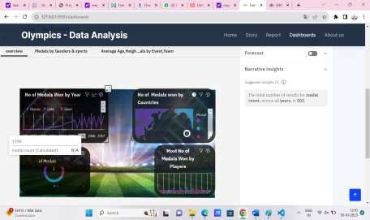

No Of Visualizations/ Graphs

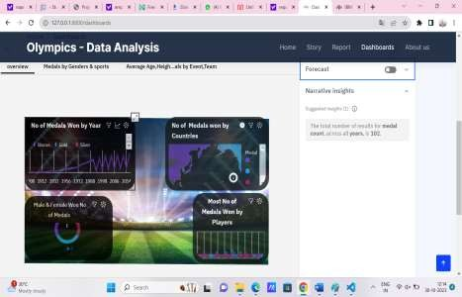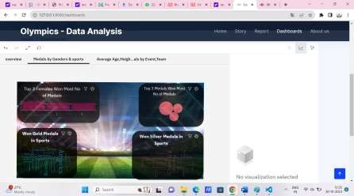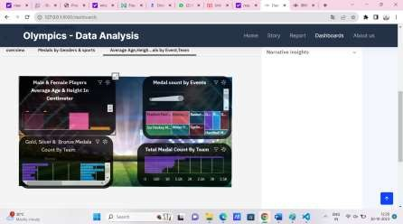

.

1. **RESULT**

**HOME**

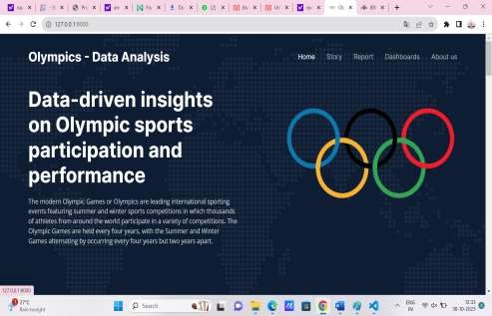

## STORY

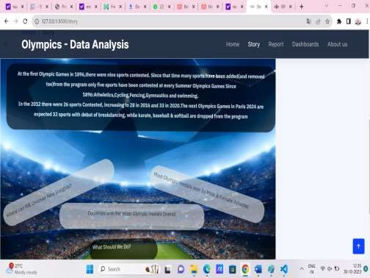

.

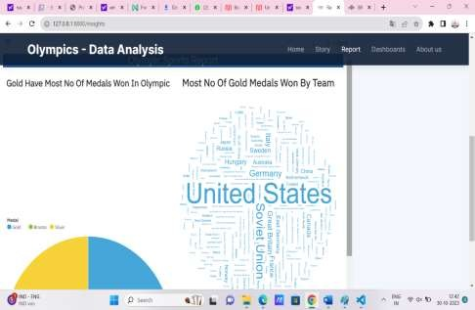

**REPORT**

**DASHBOARD**



Figure 1

,



Figure 2,3

1. **ADVANTAGES AND DISADVANTAGES**

## Advantages of the Project:

**Data-Driven Insights**: The project leverages data analytics to provide evidence- based insights into Olympic sports participation and performance, enabling stakeholders to make informed decisions.

**Comprehensive Analysis:** The project considers various aspects, including sports participation, performance analysis, influential factors, and predictive modeling, providing a holistic understanding of the Olympic sports landscape.

**Actionable Recommendations:** The project offers actionable recommendations based on the analysis, empowering stakeholders to implement strategies to enhance sports participation, improve performance outcomes, and allocate resources effectively.

## Disadvantages of the Project:

* **Data Limitations:** The project's success heavily relies on the availability, quality, and completeness of the data. Inaccurate or incomplete data may lead to biased or limited insights, impacting the overall effectiveness of the analysis.

# CONCLUSION

In conclusion, data-driven insights on Olympics sports participation and performance play a crucial role in shaping the world of sports. By analyzing vast amounts of data from various sources, we can derive valuable information that has far-reaching implications for athletes, sports organizations, host cities, and policymakers.

In the realm of sports, data-driven insights empower stakeholders with knowledge to make informed decisions, maximize athlete potential, and foster a culture of fair competition and inclusivity. As technology and data analytics continue to advance, the impact of data-driven insights on Olympics sports participation and performance will only grow, enriching the world of sports and enhancing the Olympic Games' legacy for generations to come.

# FUTURE SCOPE

The future scope for data-driven insights on Olympics sports participation and

performance is promising and holds several exciting possibilities. As technology and

data analytics continue to evolve, we can expect the following advancements and developments in this domain:

|  |  |  |
| --- | --- | --- |
|  |  | **Real-Time Analytics:** |
|  |  | time analytics will become more feasible. During the Olympics, data-driven insights can be generated and shared instantly, providing coaches, athletes, and viewers with up-to-date information and analysis.  **Advanced Predictive Modeling:** Predictive analytics will become more sophisticated, allowing for more accurate predictions of athlete performance, medal counts, and sports trends. This will aid in strategic planning for athletes, teams, and sports organizations.  **Big Data and AI Integration:** The use of big data and artificial intelligence (AI) will enable more complex and comprehensive analysis of vast datasets, leading to deeper insights and uncovering hidden patterns in sports participation and performance.  **IoT and Wearable Technology:** The integration of Internet of Things (IoT) devices and wearable technology will provide real-time data on athletes' biometrics, movements, and performance during training and competitions. This data will enhanceperformance analysis and inform coaching decisions.  **Enhanced Sports Technology:** Sports equipment and technology will continue to |

evolve, supported by data insights. Innovations like smart surfaces, smart uniforms, andtraining simulators will revolutionize athlete training and performance.

**Personalized Athlete Training:** Data-driven insights will enable personalized training programs for athletes, tailored to their specific strengths and weaknesses. Athletes can receive individualized feedback, leading to optimized training and

performance outcomes.

# APPENDIX

Source Code

Index.html

<!DOCTYPE html>

<html lang="en">

<head>

<meta charset="utf-8">

<meta content="width=device-width, initial-scale=1.0" name="viewport">

<title>Olympics Data Analysis</title>

<meta content="" name="description">

<meta content="" name="keywords">

<!-- Favicons -->

<link href="static/assets/img/favicon.png" rel="icon">

<link href="static/assets/img/apple-touch-icon.png" rel="apple-touch-icon">

<!-- Google Fonts -->

<link rel="preconnect" href="https://fonts.googleapis.com">

<link rel="preconnect" href="https://fonts.gstatic.com" crossorigin>

<link href=["https://fonts.googleapis.com/css2?family=Open+Sans:ital,wght@0,300;0,400;0,500;0,6](https://fonts.googleapis.com/css2?family=Open%2BSans%3Aital%2Cwght%400%2C300%3B0%2C400%3B0%2C500%3B0%2C6) 00;0,700;1,300;1,400;1,600;1,700&family=Poppins:ital,wght@0,300;0,400;0,500;0,600;0,700;

1,300;1,400;1,500;1,600;1,700&family=Inter:ital,wght@0,300;0,400;0,500;0,600;0,700;1,300

;1,400;1,500;1,600;1,700&display=swap" rel="stylesheet">

<!-- Vendor CSS Files -->

<link href="static/assets/vendor/bootstrap/css/bootstrap.min.css" rel="stylesheet">

<link href="static/assets/vendor/bootstrap-icons/bootstrap-icons.css" rel="stylesheet">

<link href="static/assets/vendor/fontawesome-free/css/all.min.css" rel="stylesheet">

<link href="static/assets/vendor/glightbox/css/glightbox.min.css" rel="stylesheet">

<link href="static/assets/vendor/swiper/swiper-bundle.min.css" rel="stylesheet">

<link href="static/assets/vendor/aos/aos.css" rel="stylesheet">

<!-- Template Main CSS File -->

<link href="static/assets/css/main.css" rel="stylesheet">

<!-- =======================================================

* Template Name: Logis
* Updated: May 30 2023 with Bootstrap v5.3.0
* Template URL: https://bootstrapmade.com/logis-bootstrap-logistics-website-template/
* Author: BootstrapMade.com
* License: https://bootstrapmade.com/license/

======================================================== -->

</head>

<body>

<!-- ======= Header ======= -->

<header id="header" class="header d-flex align-items-center fixed-top">

<div class="container-fluid container-xl d-flex align-items-center justify-content- between">

<a href="{{url_for('home')}}" class="logo d-flex align-items-center">

<!-- Uncomment the line below if you also wish to use an image logo -->

<!-- <img src="assets/img/logo.png" alt=""> -->

<h1>Olympics - Data Analysis</h1>

</a>

<i class="mobile-nav-toggle mobile-nav-show bi bi-list"></i>

<i class="mobile-nav-toggle mobile-nav-hide d-none bi bi-x"></i>

<nav id="navbar" class="navbar">

<ul>

<li><a href="{{url_for('home')}}" class="active">Home</a></li>

<li><a href="{{url_for('story')}}">Story</a></li>

<li><a href="{{url_for('insights')}}">Report</a></li>

<li><a href="{{url_for('dashboards')}}">Dashboards</a></li>

<li><a href="{{url_for('about')}}">About us</a></li>

</ul>

</nav><!-- .navbar -->

</div>

</header><!-- End Header -->

<!-- End Header -->

<!-- ======= Hero Section ======= -->

<section id="hero" class="hero d-flex align-items-center">

<div class="container">

<div class="row gy-4 d-flex justify-content-between">

<div class="col-lg-6 order-2 order-lg-1 d-flex flex-column justify-content- center">

<h2 data-aos="fade-up">Data-driven insights on Olympic sports participation and performance</h2>

<p data-aos="fade-up" data-aos-delay="100">

The modern Olympic Games or Olympics are leading international sporting events featuring summer and winter sports competitions in which thousands of athletes from around the world participate in a variety of competitions. The Olympic Games are held every four years, with the Summer and Winter Games alternating by occurring every four years but two years apart.

</p>

<div class="row gy-4" data-aos="fade-up" data-aos-delay="400" >

<div class="col-lg-3 col-6">

<div class="stats-item text-center w-100 h-100">

<span data-purecounter-start="0" data-purecounter-end="206" data- purecounter-duration="1.5" class="purecounter"></span>

<p>Countries</p>

</div>

</div><!-- End Stats Item -->

<div class="col-lg-3 col-6">

<div class="stats-item text-center w-100 h-100">

<span data-purecounter-start="0" data-purecounter-end="66" data- purecounter-duration="1.5" class="purecounter"></span>

<p>Sports</p>

</div>

</div><!-- End Stats Item -->

<div class="col-lg-3 col-6">

<div class="stats-item text-center w-100 h-100">

<span data-purecounter-start="0" data-purecounter-end="134732" data- purecounter-duration="1.5" class="purecounter"></span>

<p>&nbsp;&nbsp;Participants</p>

</div>

</div><!-- End Stats Item -->

</div>

</div>

alt="">

<div class="col-lg-5 order-1 order-lg-2 hero-img" data-aos="zoom-out">

<img src="static/assets/img/olympics.png" class="img-fluid mb-3 mb-lg-0"

</div>

</div>

</div>

</section><!-- End Hero Section -->

<main id="main">

<!-- ======= About Us Section ======= -->

<section id="about" class="about pt-0">

<div class="container" data-aos="fade-up">

first">

<div class="row gy-4">

<div class="col-lg-6 position-relative align-self-start order-lg-last order-

<img src="static/assets/img/History.webp" class="img-fluid" alt="">

<a href="https://youtu.be/mQ94xbXnYu4" class="glightbox play-btn"></a>

</div>

<div class="col-lg-6 content order-last order-lg-first">

<h3>History</h3>

<p>

The 1896 Summer Olympics, officially known as the Games of the I Olympiad

and commonly known as Athens 1896, was the first international Olympic Games held in modern history. Organised by the International Olympic Committee (IOC), which had been created by French aristocrat Pierre de Coubertin, it was held in Athens, Greece, from 6 to 15 April 1896.

Fourteen nations (according to the IOC, though the number is subject to interpretation) and 241 athletes (all males; this number is also disputed) took part in the games. Participants were all European, or living in Europe, with the exception of

the United States team. Over 65% of the competing athletes were Greek. Winners were given a silver medal, while runners-up received a copper medal.

</p>

</div>

</div>

<div class='History' id='viz1688051296025' style='position: relative'>

<noscript>

<a href='#'>

<img alt=' ' src='https:&#47;&#47;public.tableau.com&#47;static&#47;images&#47;Ol&#47;OlympicAtheletd ataset_16880435094160&#47;History&#47;1_rss.png' style='border: none' />

</a>

</noscript>

<object class='tableauViz' style='display:none;'>

<param name='host_url' value='https%3A%2F%2Fpublic.tableau.com%2F' />

<param name='embed_code_version' value='3' />

<param name='site_root' value='' />

<param name='name' value='OlympicAtheletdataset_16880435094160&#47;History'

/>

<param name='tabs' value='yes' />

<param name='toolbar' value='yes' />

<param name='static_image'

value='https:&#47;&#47;public.tableau.com&#47;static&#47;images&#47;Ol&#47;OlympicAthele tdataset_16880435094160&#47;History&#47;1.png' />

<param name='animate_transition' value='yes' />

<param name='display_static_image' value='yes' />

<param name='display_spinner' value='yes' />

<param name='display_overlay' value='yes' />

<param name='display_count' value='yes' />

<param name='language' value='en-US' />

</object>

</div>

<script type='text/javascript'> var divElement =

document.getElementById('viz1688051296025');

var vizElement = divElement.getElementsByTagName('object')[0];

if ( divElement.offsetWidth > 800 )

{ vizElement.style.minWidth='1100px'; vizElement.style.maxWidth='100%'; vizElement.style.minHeight='950px'; vizElement.style.maxHeight=(divElement.offsetWidth*0.75)+'px';

} else if ( divElement.offsetWidth > 500 )

{ vizElement.style.minWidth='1100px'; vizElement.style.maxWidth='100%'; vizElement.style.minHeight='950px'; vizElement.style.maxHeight=(divElement.offsetWidth*0.75)+'px';

} else { vizElement.style.minWidth='1100px'; vizElement.style.maxWidth='100%'; vizElement.style.minHeight='1450px'; vizElement.style.maxHeight=(divElement.offsetWidth*1.77)+'px';

}

var scriptElement = document.createElement('script');

scriptElement.src = 'https://public.tableau.com/javascripts/api/viz_v1.js';

vizElement.parentNode.insertBefore(scriptElement,

vizElement);

</script>

</div>

</section><!-- End About Us Section -->

<!-- ======= Services Section ======= -->

<section id="service" class="services pt-0">

<div class="container" data-aos="fade-up">

<div class="section-header">

<span>SPORTS IN OLYMPICS</span>

<h2>SPORTS IN OLYMPICS</h2>

</div>

<div class="row gy-4">

<div class="col-lg-4 col-md-6" data-aos="fade-up" data-aos-delay="100">

<div class="card">

<div class="card-img">

<img src="static/assets/img/Gymnastics.jpg" alt="" class="img-fluid">

</div>

<h3><a href="#" class="stretched-link">Gymnastics</a></h3>

<p>

Gymnastics combines athleticism, strength, and grace as athletes perform breathtaking acrobatic routines on various apparatus such as the balance beam, uneven bars, vault, and floor exercise, showcasing their flexibility, power, and precision.

</p>

</div>

</div><!-- End Card Item -->

<div class="col-lg-4 col-md-6" data-aos="fade-up" data-aos-delay="200">

<div class="card">

<div class="card-img">

<img src="static/assets/img/Track.webp" alt="" class="img-fluid">

</div>

<h3><a href="#" class="stretched-link">Track & Field</a></h3>

<p>

Track and field events encompass a wide range of athletic disciplines, including sprints, long-distance running, hurdles, high jump, long jump, shot put, discus throw, and javelin throw. Athletes compete in individual events, pushing their physical limits and aiming for faster times, higher jumps, and longer throws.

</p>

</div>

</div><!-- End Card Item -->

<div class="col-lg-4 col-md-6" data-aos="fade-up" data-aos-delay="300">

<div class="card">

<div class="card-img">

<img src="static/assets/img/Swimming.png" alt="" class="img-fluid">

</div>

<h3><a href="#" class="stretched-link">Swimming</a></h3>

<p>

Swimmers compete in various swimming styles such as freestyle, backstroke, breaststroke, and butterfly, showcasing their speed, endurance, and technique. Races range from short sprints to longer distances, and swimmers strive to break records while demonstrating their exceptional skill in the water.

</p>

</div>

</div><!-- End Card Item -->

<div class="col-lg-4 col-md-6" data-aos="fade-up" data-aos-delay="400">

<div class="card">

<div class="card-img">

<img src="static/assets/img/Basketball.jpg" alt="" class="img-fluid">

</div>

<h3><a href="#" class="stretched-link">BasketBall</a></h3>

<p>

Basketball is a fast-paced team sport where players aim to shoot the ball into the opponent's hoop while preventing the other team from scoring. With its high-energy gameplay, skilled ball handling, and strategic teamwork, basketball captivates fans worldwide and showcases exceptional athleticism and coordination.

</p>

</div>

</div><!-- End Card Item -->

<div class="col-lg-4 col-md-6" data-aos="fade-up" data-aos-delay="500">

<div class="card">

<div class="card-img">

<img src="static/assets/img/Football.jpg" alt="" class="img-fluid">

</div>

<h3><a href="#" class="stretched-link">Football</a></h3>

<p>

Football, or soccer, is a globally popular sport that brings together teams competing to score goals by maneuvering a ball into the opponent's net. Combining speed, agility, and tactical play, football demands both individual skill and collective teamwork, captivating audiences with its passion and intensity.

</p>

</div>

</div><!-- End Card Item -->

<div class="col-lg-4 col-md-6" data-aos="fade-up" data-aos-delay="600">

<div class="card">

<div class="card-img">

<img src="static/assets/img/Table Tennis.webp" alt="" class="img-fluid">

</div>

<h3><a href="#" class="stretched-link">Table Tennis</a></h3>

<p>

Table tennis, also known as ping pong, is a fast-paced racket sport played on a table. Players showcase lightning-fast reflexes, precision, and strategic shot placement as they compete in singles or doubles matches, making table tennis a thrilling sport that requires exceptional hand-eye coordination and agility.

</p>

</div>

</div><!-- End Card Item -->

</div>

</div>

</section><!-- End Services Section -->

<!-- ======= Call To Action Section ======= -->

<section id="call-to-action" class="call-to-action">

<div class="container" data-aos="zoom-out">

<div class="row justify-content-center">

<div class="col-lg-8 text-center">

<h3>Data Analysis</h3>

<p> In this project we have analyzed data to gain insights about Performance of countries, Atheltes and various kind of factors which play a key role in Olympics</p>

<a class="cta-btn" href="{{url_for('insights')}}">Gain Insights</a>

</div>

</div>

</div>

</section><!-- End Call To Action Section -->

<!-- ======= Testimonials Section ======= -->

<section id="testimonials" class="testimonials">

<div class="container">

<div class="slides-1 swiper" data-aos="fade-up">

<div class="swiper-wrapper">

alt="">

get back up.

<div class="swiper-slide">

<div class="testimonial-item">

<img src="static/assets/img/team/Mary Kom.jpeg" class="testimonial-img"

<h3>Mary Kom</h3>

<h4>Indian professional boxer </h4>

<p>

<i class="bi bi-quote quote-icon-left"></i>

It's not about how many times you fall down, but how many times you

<i class="bi bi-quote quote-icon-right"></i>

</p>

</div>

</div><!-- End testimonial item -->

alt="">

<div class="swiper-slide">

<div class="testimonial-item">

<img src="static/assets/img/team/PV Sindhu.jpg" class="testimonial-img"

<h3>PV Sindhu</h3>

<h4>Indian badminton player</h4>

<p>

<i class="bi bi-quote quote-icon-left"></i>

Dreams do come true if you work hard and never give up

<i class="bi bi-quote quote-icon-right"></i>

</p>

</div>

</div><!-- End testimonial item -->

<div class="swiper-slide">

img" alt="">

<div class="testimonial-item">

<img src="static/assets/img/team/Usain Bolt.webp" class="testimonial-

<h3>Usain Bolt</h3>

<h4>Jamaican sprinter</h4>

<p>

<i class="bi bi-quote quote-icon-left"></i>

Don't think about the start of the race; think about the ending

<i class="bi bi-quote quote-icon-right"></i>

</p>

</div>

</div><!-- End testimonial item -->

</div>

<div class="swiper-pagination"></div>

</div>

</div>

</section><!-- End Testimonials Section -->

</main><!-- End #main -->

<!-- ======= Footer ======= -->

<footer id="footer" class="footer">

<div class="container">

<div class="row gy-4">

<div class="col-lg-5 col-md-12 footer-info">

<h2>Olympics Data Analysis</h2>

<p>Hope you found something insightful in our project</p>

</div>

</div>

</div>

</footer><!-- End Footer -->

<!-- End Footer -->

<a href="#" class="scroll-top d-flex align-items-center justify-content-center"><i class="bi bi-arrow-up-short"></i></a>

<div id="preloader"></div>

<!-- Vendor JS Files -->

<script src="static/assets/vendor/bootstrap/js/bootstrap.bundle.min.js"></script>

<script src="static/assets/vendor/purecounter/purecounter_vanilla.js"></script>

<script src="static/assets/vendor/glightbox/js/glightbox.min.js"></script>

<script src="static/assets/vendor/swiper/swiper-bundle.min.js"></script>

<script src="static/assets/vendor/aos/aos.js"></script>

<script src="static/assets/vendor/php-email-form/validate.js"></script>

<!-- Template Main JS File -->

<script src="static/assets/js/main.js"></script>

</body>

</html>

Dashboard.html

<!DOCTYPE html>

<html lang="en">

<head>

<meta charset="utf-8">

<meta content="width=device-width, initial-scale=1.0" name="viewport">

<title>Dashboards</title>

<meta content="" name="description">

<meta content="" name="keywords">

<!-- Favicons -->

<link href="static/assets/img/favicon.png" rel="icon">

<link href="static/assets/img/apple-touch-icon.png" rel="apple-touch-icon">

<!-- Google Fonts -->

<link rel="preconnect" href="https://fonts.googleapis.com">

<link rel="preconnect" href="https://fonts.gstatic.com" crossorigin>

<link href=["https://fonts.googleapis.com/css2?family=Open+Sans:ital,wght@0,300;0,400;0,500;0,6](https://fonts.googleapis.com/css2?family=Open%2BSans%3Aital%2Cwght%400%2C300%3B0%2C400%3B0%2C500%3B0%2C6) 00;0,700;1,300;1,400;1,600;1,700&family=Poppins:ital,wght@0,300;0,400;0,500;0,600;0,700;

1,300;1,400;1,500;1,600;1,700&family=Inter:ital,wght@0,300;0,400;0,500;0,600;0,700;1,300

;1,400;1,500;1,600;1,700&display=swap" rel="stylesheet">

<!-- Vendor CSS Files -->

<link href="static/assets/vendor/bootstrap/css/bootstrap.min.css" rel="stylesheet">

<link href="static/assets/vendor/bootstrap-icons/bootstrap-icons.css" rel="stylesheet">

<link href="static/assets/vendor/fontawesome-free/css/all.min.css" rel="stylesheet">

<link href="static/assets/vendor/glightbox/css/glightbox.min.css" rel="stylesheet">

<link href="static/assets/vendor/swiper/swiper-bundle.min.css" rel="stylesheet">

<link href="static/assets/vendor/aos/aos.css" rel="stylesheet">

<!-- Template Main CSS File -->

<link href="static/assets/css/main.css" rel="stylesheet">

<!-- =======================================================

* Template Name: Logis
* Updated: May 30 2023 with Bootstrap v5.3.0
* Template URL: https://bootstrapmade.com/logis-bootstrap-logistics-website-template/
* Author: BootstrapMade.com
* License: https://bootstrapmade.com/license/

======================================================== -->

</head>

<body>

<!-- ======= Header ======= -->

<header id="header" class="header d-flex align-items-center fixed-top">

<div class="container-fluid container-xl d-flex align-items-center justify-content- between">

<a href="{{url_for('home')}}" class="logo d-flex align-items-center">

<!-- Uncomment the line below if you also wish to use an image logo -->

<!-- <img src="assets/img/logo.png" alt=""> -->

<h1>Olympics - Data Analysis</h1>

</a>

<i class="mobile-nav-toggle mobile-nav-show bi bi-list"></i>

<i class="mobile-nav-toggle mobile-nav-hide d-none bi bi-x"></i>

<nav id="navbar" class="navbar">

<ul>

<li><a href="{{url_for('home')}}">Home</a></li>

<li><a href="{{url_for('story')}}">Story</a></li>

<li><a href="{{url_for('insights')}}" >Report</a></li>

<li><a href="{{url_for('dashboards')}}" class="active">Dashboards</a></li>

<li><a href="{{url_for('about')}}">About us</a></li>

</ul>

</nav><!-- .navbar -->

</div>

</header><!-- End Header -->

<!-- End Header -->

<main id="main">

<!-- ======= Breadcrumbs ======= -->

<div class="breadcrumbs">

<div class="page-header d-flex align-items-center" style="background-image: url('static/assets/img/Header.jpg'); height: 500px;">

<div class="container position-relative">

<div class="row d-flex justify-content-center">

<div class="col-lg-6 text-center">

<h2>Dashboards</h2>

<p>

The different Dashboards provide different form of information. Dashboards are basically a well collected,arranged and designed architecture of visualizations. All Visualizations which are logically connected with each other can be depicted together in single containers like Dashboard.

</p>

</div>

</div>

</div>

</div>

<nav>

<div class="container">

<ol>

<li><a href="{{url_for('home')}}">Home</a></li>

<li>Dashboards</li>

</ol>

</div>

<iframe src="https://us3.ca.analytics.ibm.com/bi/?perspective=dashboard&amp;pathRef=.my_folders% 2FOlympic%2BDashboard&amp;closeWindowOnLastView=true&amp;ui_appbar=false&amp;ui_navbar=f alse&amp;shareMode=embedded&amp;action=view&amp;mode=dashboard&amp;subView=model0000018b 3cdb9b65_00000003" width="1150" height="900" frameborder="0" gesture="media" allow="encrypted-media" allowfullscreen=""></iframe>

</nav>

</div><!-- End Breadcrumbs -->

<div class='Dashboard1' id='viz1688051822276' style='position: relative'>

<noscript>

<a href='#'>

</a>

</noscript>

<object class='tableauViz' style='display:none;'><param name='host_url' value='https%3A%2F%2Fpublic.tableau.com%2F' />

<param name='embed_code_version' value='3' />

<param name='site_root' value='' />

<param name='name' value='OlympicAtheletdataset_16880435094160&#47;SportsEventsdashbaord' />

<param name='tabs' value='yes' />

<param name='toolbar' value='yes' />

<param name='static_image' value='https:&#47;&#47;public.tableau.com&#47;static&#47;images&#47;Ol&#47;OlympicAthele tdataset_16880435094160&#47;SportsEventsdashbaord&#47;1.png' />

<param name='animate_transition' value='yes' />

<param name='display_static_image' value='yes' />

<param name='display_spinner' value='yes' />

<param name='display_overlay' value='yes' />

<param name='display_count' value='yes' />

<param name='language' value='en-US' />

</object>

</div>

</footer><!-- End Footer -->

<!-- End Footer -->

<a href="#" class="scroll-top d-flex align-items-center justify-content-center"><i class="bi bi-arrow-up-short"></i></a>

<div id="preloader"></div>

<!-- Vendor JS Files -->

<script src="static/assets/vendor/bootstrap/js/bootstrap.bundle.min.js"></script>

<script src="static/assets/vendor/purecounter/purecounter_vanilla.js"></script>

<script src="static/assets/vendor/glightbox/js/glightbox.min.js"></script>

<script src="static/assets/vendor/swiper/swiper-bundle.min.js"></script>

<script src="static/assets/vendor/aos/aos.js"></script>

<script src="static/assets/vendor/php-email-form/validate.js"></script>

<!-- Template Main JS File -->

<script src="static/assets/js/main.js"></script>

</body>

</html>

Insights.html

<!DOCTYPE html>

<html lang="en">

<head>

<meta charset="utf-8">

<meta content="width=device-width, initial-scale=1.0" name="viewport">

<title>Report</title>

<meta content="" name="description">

<meta content="" name="keywords">

<!-- Favicons -->

<link href="static/assets/img/favicon.png" rel="icon">

<link href="static/assets/img/apple-touch-icon.png" rel="apple-touch-icon">

<!-- Google Fonts -->

<link rel="preconnect" href="https://fonts.googleapis.com">

<link rel="preconnect" href="https://fonts.gstatic.com" crossorigin>

<link href=["https://fonts.googleapis.com/css2?family=Open+Sans:ital,wght@0,300;0,400;0,500;0,6](https://fonts.googleapis.com/css2?family=Open%2BSans%3Aital%2Cwght%400%2C300%3B0%2C400%3B0%2C500%3B0%2C6) 00;0,700;1,300;1,400;1,600;1,700&family=Poppins:ital,wght@0,300;0,400;0,500;0,600;0,700;

1,300;1,400;1,500;1,600;1,700&family=Inter:ital,wght@0,300;0,400;0,500;0,600;0,700;1,300

;1,400;1,500;1,600;1,700&display=swap" rel="stylesheet">

<!-- Vendor CSS Files -->

<link href="static/assets/vendor/bootstrap/css/bootstrap.min.css" rel="stylesheet">

<link href="static/assets/vendor/bootstrap-icons/bootstrap-icons.css" rel="stylesheet">

<link href="static/assets/vendor/fontawesome-free/css/all.min.css" rel="stylesheet">

<link href="static/assets/vendor/glightbox/css/glightbox.min.css" rel="stylesheet">

<link href="static/assets/vendor/swiper/swiper-bundle.min.css" rel="stylesheet">

<link href="static/assets/vendor/aos/aos.css" rel="stylesheet">

<!-- Template Main CSS File -->

<link href="static/assets/css/main.css" rel="stylesheet">

<!-- =======================================================

* Template Name: Logis
* Updated: May 30 2023 with Bootstrap v5.3.0
* Template URL: https://bootstrapmade.com/logis-bootstrap-logistics-website-template/
* Author: BootstrapMade.com
* License: https://bootstrapmade.com/license/

======================================================== -->

</head>

<body>

<!-- ======= Header ======= -->

<header id="header" class="header d-flex align-items-center fixed-top">

<div class="container-fluid container-xl d-flex align-items-center justify-content- between">

<a href="{{url_for('home')}}" class="logo d-flex align-items-center">

<!-- Uncomment the line below if you also wish to use an image logo -->

<!-- <img src="assets/img/logo.png" alt=""> -->

<h1>Olympics - Data Analysis</h1>

</a>

<i class="mobile-nav-toggle mobile-nav-show bi bi-list"></i>

<i class="mobile-nav-toggle mobile-nav-hide d-none bi bi-x"></i>

<nav id="navbar" class="navbar">

<ul>

<li><a href="{{url_for('home')}}">Home</a></li>

<li><a href="{{url_for('story')}}">Story</a></li>

<li><a href="{{url_for('insights')}}" class="active">Report</a></li>

<li><a href="{{url_for('dashboards')}}">Dashboards</a></li>

<li><a href="{{url_for('about')}}">About us</a></li>

</ul>

</nav><!-- .navbar -->

</div>

</header><!-- End Header -->

<!-- End Header -->

<main id="main">

<!-- ======= Breadcrumbs ======= -->

<div class="breadcrumbs">

<div class="page-header d-flex align-items-center" style="background-image: url('static/assets/img/Header.jpg'); height: 500px;">

<div class="container position-relative">

<div class="row d-flex justify-content-center">

<div class="col-lg-6 text-center">

<h2>Important Insights</h2>

<p>

The following provides meaningful insights and factors responsible for Top performing Countries in the Olympics.

</p>

</div>

</div>

</div>

</div>

<nav>

<div class="container">

<ol>

<li><a href="index.html">Home</a></li>

<li>Report</li>

</ol>

</div>

<iframe src="https://us3.ca.analytics.ibm.com/bi/?pathRef=.my_folders%2FReport%2FOlympic%2BRepor t&amp;closeWindowOnLastView=true&amp;ui_appbar=false&amp;ui_navbar=false&amp;shareMode=e mbedded&amp;action=run&amp;format=HTML&amp;prompt=false" width="950" height="800" frameborder="0" gesture="media" allow="encrypted-media" allowfullscreen=""></iframe>

</nav>

</div><!-- End Breadcrumbs -->

<!-- Template Main JS File -->

<script src="static/assets/js/main.js"></script>

</body>

</html>

Story.html

<!DOCTYPE html>

<html lang="en">

<head>

<meta charset="utf-8">

<meta content="width=device-width, initial-scale=1.0" name="viewport">

<title>Story</title>

<meta content="" name="description">

<meta content="" name="keywords">

<!-- Favicons -->

<link href="static/assets/img/favicon.png" rel="icon">

<link href="static/assets/img/apple-touch-icon.png" rel="apple-touch-icon">

<!-- Google Fonts -->

<link rel="preconnect" href="https://fonts.googleapis.com">

<link rel="preconnect" href="https://fonts.gstatic.com" crossorigin>

<link href=["https://fonts.googleapis.com/css2?family=Open+Sans:ital,wght@0,300;0,400;0,500;0,6](https://fonts.googleapis.com/css2?family=Open%2BSans%3Aital%2Cwght%400%2C300%3B0%2C400%3B0%2C500%3B0%2C6) 00;0,700;1,300;1,400;1,600;1,700&family=Poppins:ital,wght@0,300;0,400;0,500;0,600;0,700;

1,300;1,400;1,500;1,600;1,700&family=Inter:ital,wght@0,300;0,400;0,500;0,600;0,700;1,300

;1,400;1,500;1,600;1,700&display=swap" rel="stylesheet">

<!-- Vendor CSS Files -->

<link href="static/assets/vendor/bootstrap/css/bootstrap.min.css" rel="stylesheet">

<link href="static/assets/vendor/bootstrap-icons/bootstrap-icons.css" rel="stylesheet">

<link href="static/assets/vendor/fontawesome-free/css/all.min.css" rel="stylesheet">

<link href="static/assets/vendor/glightbox/css/glightbox.min.css" rel="stylesheet">

<link href="static/assets/vendor/swiper/swiper-bundle.min.css" rel="stylesheet">

<link href="static/assets/vendor/aos/aos.css" rel="stylesheet">

<!-- Template Main CSS File -->

<link href="static/assets/css/main.css" rel="stylesheet">

<!-- =======================================================

* Template Name: Logis
* Updated: May 30 2023 with Bootstrap v5.3.0
* Template URL: https://bootstrapmade.com/logis-bootstrap-logistics-website-template/
* Author: BootstrapMade.com
* License: https://bootstrapmade.com/license/

======================================================== -->

</head>

<body>

<!-- ======= Header ======= -->

<header id="header" class="header d-flex align-items-center fixed-top">

<div class="container-fluid container-xl d-flex align-items-center justify-content- between">

<a href="{{url_for('home')}}" class="logo d-flex align-items-center">

<!-- Uncomment the line below if you also wish to use an image logo -->

<!-- <img src="assets/img/logo.png" alt=""> -->

<h1>Olympics - Data Analysis</h1>

</a>

<i class="mobile-nav-toggle mobile-nav-show bi bi-list"></i>

<i class="mobile-nav-toggle mobile-nav-hide d-none bi bi-x"></i>

<nav id="navbar" class="navbar">

<ul>

<li><a href="{{url_for('home')}}" >Home</a></li>

<li><a href="{{url_for('story')}}" class="active">Story</a></li>

<li><a href="{{url_for('insights')}}">Report</a></li>

<li><a href="{{url_for('dashboards')}}">Dashboards</a></li>

<li><a href="{{url_for('about')}}">About us</a></li>

</ul>

</nav><!-- .navbar -->

</div>

</header><!-- End Header -->

<!-- End Header -->

<main id="main">

<!-- ======= Breadcrumbs ======= -->

<div class="breadcrumbs">

<div class="page-header d-flex align-items-center" style="background-image: url('static/assets/img/Header.jpg'); height: 500px;">

<div class="container position-relative">

<div class="row d-flex justify-content-center">

<div class="col-lg-6 text-center">

<h2>Story</h2>

<p>

The story describes a visual narrative of all the visualizations and dashboard of this project. The Story explains the performances of countries in the Olympics, factors responsible and provides helpful insights about the Olympics.

</p>

</div>

</div>

</div>

</div>

<nav>

<div class="container">

<ol>

<li><a href="{{url_for('home')}}">Home</a></li>

<li>Story</li>

</ol>

</div>

<iframe src="https://us3.ca.analytics.ibm.com/bi/?perspective=story&amp;pathRef=.my_folders%2FSt ory%2FOlympic%2BSports%2BStory&amp;closeWindowOnLastView=true&amp;ui_appbar=false&amp;ui

_navbar=false&amp;shareMode=embedded&amp;action=view&amp;sceneId=model0000018b430e5342_0

0000002&amp;sceneTime=0" width="950" height="800" frameborder="0" gesture="media" allow="encrypted-media" allowfullscreen=""></iframe>

</nav>

</div><!-- End Breadcrumbs -->

<!-- End Footer -->

<a href="#" class="scroll-top d-flex align-items-center justify-content-center"><i class="bi bi-arrow-up-short"></i></a>

<div id="preloader"></div>

<!-- Vendor JS Files -->

<script src="static/assets/vendor/bootstrap/js/bootstrap.bundle.min.js"></script>

<script src="static/assets/vendor/purecounter/purecounter_vanilla.js"></script>

<script src="static/assets/vendor/glightbox/js/glightbox.min.js"></script>

<script src="static/assets/vendor/swiper/swiper-bundle.min.js"></script>

<script src="static/assets/vendor/aos/aos.js"></script>

<script src="static/assets/vendor/php-email-form/validate.js"></script>

<!-- Template Main JS File -->

<script src="static/assets/js/main.js"></script>

</body>

</html>

app.py

from flask import Flask,render_template,url_for app = Flask( name )

@app.route("/") def home():

return render_template("index.html",

story_url=url_for("story"), insights_url=url_for("insights"), dashboards_url=url_for("dashboards"), about_url=url_for("about"))

@app.route("/story") def story():

return render_template("story.html")

@app.route("/insights") def insights():

return render_template("insights.html")

@app.route("/dashboards") def dashboards():

return render_template("dashboards.html")

@app.route("/about") def about():

return render_template("about.html")

if name == " main ": app.run(debug=False, port=8000)

**GitHub & Project Demo Link**

**GitHub Link:**

## [https://github.com/BalaSSbala/Data-Driven-Insights-On-Olympic-Sports- Participation-And-Performance](https://github.com/BalaSSbala/Data-Driven-Insights-On-Olympic-Sports-%20Participation-And-Performance)

**Demo Link:**

[**https://drive.google.com/file/d/1CtXYLOcJL2aStzPSnB4-NTgvLg5szSTg/view?usp=sharing**](%20%20%20%20https:/drive.google.com/file/d/1CtXYLOcJL2aStzPSnB4-NTgvLg5szSTg/view?usp=sharing)

THANK YOU…